COMP 272 assignment 2 question 3:

MARTA SKRETA (student ID: 333674)

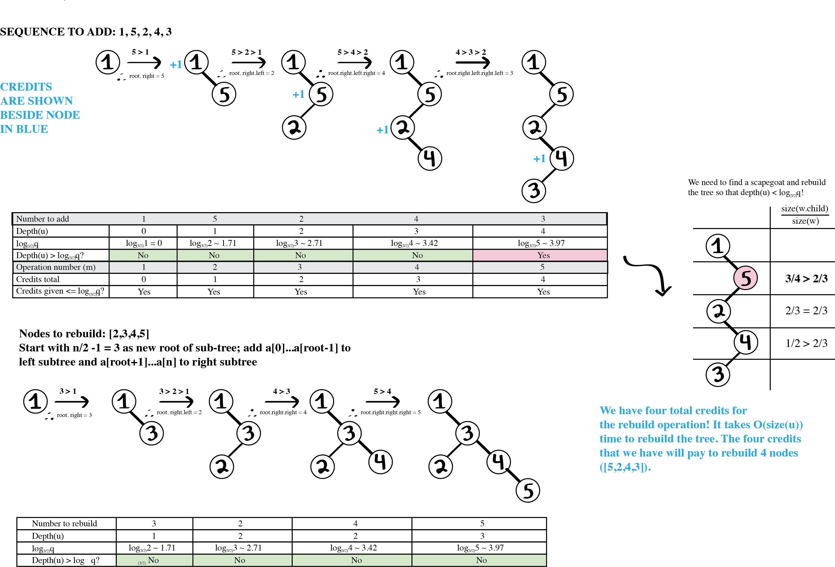

To build the tree, I used the binary search tree property: if the input is greater than node u, I added it to u.left; if it is greater, I added it to u.right. For each node addition, I added one credit to my reserve. When I added the last node, 3, however, the depth of that node (4) was greater than log(3/2)q, where q is the upperbound on the number of nodes. Thus, I had to find a scapegoat to rebuild the tree. The scapegoat chosen was 5, because it was the first node that had size(u.child)/size(u) of greater than 2/3 (indicating great imbalance). Rebuilding the subtree takes O(size(u)) time; because I had to rebuild 4 nodes, it would take O(size(u)) time. Because I had added in 4 nodes when initially building the binary tree, I had 4 credits to my disposal to rebuild the subtree.